**Client: American Express April'16 – June’18**

**Location: Phoenix AZ**

**Role: AWS / DevOps Engineer**

The American Express Company, also known as Amex, is an American [multinational](https://www.bing.com/search?q=Multinational%20corporation%20wikipedia) [financial services](https://www.bing.com/search?q=Financial%20services%20wikipedia) corporation headquartered in [Three World Financial Center](https://www.bing.com/search?q=Three%20World%20Financial%20Center%20wikipedia) in [New York City](https://www.bing.com/search?q=New%20York%20City%20wikipedia)

# Home address: 19214 N 32nd Dr

## Phoenix, AZ 85027

American Express 19640 N. 31st Ave, Phoenix, AZ 85027

**Client: Reflexis Inc April'16 – June’18**

**Location: Kennesaw GA(Gerogia)**

**Role: AWS / DevOps Engineer** 125 TownPark Dr. Ste. 400

Kennesaw, GA  30144

Reflexis is the leading provider of real-time store operations solutions having been selected by more than 275 global retailers to simplify store operations, optimize labor spend, and improve store execution.

**Client: PwC Sep’14 - Dec ‘15**

**Location: NYC, NY**

**Role: Build and Release Engineer**

accounting firm offers professional services like offering audit, assurance services, taxation, management consulting, advisory, actuarial, corporate finance and legal services.

**Client: Tata Consultancy Services July’12 –Aug’14**

**Location: Hyderabad, India**

**Role: Linux Administrator**

**323 Navarre Ave #403**Coral Gables, FL 33134

# 323 Navarre Ave #403 Coral Gables, FL 33134

# 323 Navarre Ave #403 Coral Gables, FL 33134

My major responsibilities are mostly into built and release using Devops related tools , previously It was on permesis, but now mostly on cloud bases as its very easy to scale and handle web application and database servers,

Also, cloud gives central access to all resources and its very cheap to maintain with no upfront cost.

* I am having around seven years total IT experience mostly into devops and cloud architecture. well, I started my career as a linux administrature and then I moved to built and release environment where I use to deploy web application onto a servers like Tomcat, glass fish, jboss, weblogic. Then slowly I moved into cloud based platform to enhance my career further. I am having experience in almost all three types of IT Designes which are platform-as-a-service and software-as-a-service. Actually code-as-a-service
* With regards to cloud, I am having really good experience with AWS and its services,
* AWS – EC2, EBS, ELB, S3, Route53, SES, Kinesis, Redshift, Load Balancing
* CI/CD tool Jenkins
* Configuring tools, Chef, Puppet, Jira, Ansible, Dockers, Vagrant, Git Hub, Jira,

|  |  |
| --- | --- |
| Build Tools | Maven, Ant |
| CI Tools | **Jenkins, Hudson, Bamboo** |
| Application Servers | **Tomcat, JBoss, WebSphere** |
| Version Control Tools | **GIT, SVN** |
| Scripting Languages | **Python, Shell, Groovy** |
| Operating Systems | **Linux, MS Windows, Ubuntu, CentOS** |
| Provisioning /Containerization Tools | **Docker, Ansible, Chef, Puppet** |
| Clouds | **AWS, Azure, GCP** |
| Languages | **Java, Python, J2EE** |
| Orchestration Tools | **Kubernetes, Mesos** |
| Databases | **My SQL, Oracle, Mongo DB** |
| Monitoring Tools | **Nagios, Splunk, Cloud Watch** |
| Development Tools | **Eclipse, Net Beans, IntelliJ, VMWare** |

6+

* experienced in Automating, Developing, Configuring and deploying instances on **AWS, Azure** and **Rackspace** cloud environments and Data centers, Automation and Unix administration and transformed traditional environments to virtualized environments with, AWS – EC2, EBS, ELB, S3, Route53, SES, Kinesis, Redshift, Load Balancing, Jenkins, Chef, Puppet, Jira, Ansible, Dockers, Vagrant, Git Hub, Jira,

Kubernates:

It is used to manage containers, usually dockers containers, due to its ability to automatically scale up and down the traffic generated onto the production server.

If the container is experiencing heavy traffic then automatically kubernates launches another container which is a copy to existing production server and automatiocally add a DNS name and IP address and launch to balance the traffic load.

It helps for storage Orchestartion, automatically mount the storage or add any

* Used **Kubernetes** to manage containerized applications using its nodes, Config Maps, selector, Services and deployed application containers as **Pods**.
* Created Ansible playbooks which are the entry point for **Ansible** provisioning, where the automation is defined through tasks using **YAML** format and Run Ansible Scripts to depending on provision to Dev servers. Converted a slow and manual procedure to dynamic API generated procedures in **Ansible**.

SRE Site Reliability Engineering

**Site Reliability Engineering** falls under more or less traditional operations, but heavily automated and version controlled, what is also called [Infrastructure as Code](https://en.wikipedia.org/wiki/Infrastructure_as_Code). It is a well defined **vertical role**. In modern DevOps this is the vertical slice that relates to Operations. You can have a team of SRE.

**DevOps** as such is a cultural change for an organization. In addition to the vertical, top down, management structure, it creates a horizontal connection between the teams along the [delivery](https://en.wikipedia.org/wiki/Continuous_delivery) paths of work throughout the [value chains](https://en.wikipedia.org/wiki/Value_chain). For an engineer it is a loosely defined **horizontal role** binding several teams together, ensuring that work passes smoothly and quickly throughout the organization. You cannot have a team of DevOps engineers, that is an oxymoron, as spanning the team boundaries is a crucial part of the role.

Anthem va(insurance)

My employer details are:

Raju Chapala,

Canoesys Inc,

Direct : 847-960-5836,

E-Mail: [raju@canoesys.com](mailto:raju@canoesys.com).

References:

Vijender Mali

Reporting Manger

American Express

Vijenderreddy.[mali@aexp.com](mailto:mali@aexp.com)

Contact: 724-466-2459

Gopi Kollipara

Tech Lead

Reflexis Inc

[gopi.kollipara@reflexis.com](mailto:gopi.kollipara@reflexis.com)

Contact : 636-887-6090

E-mail is the best way to reach Vijender Reddy

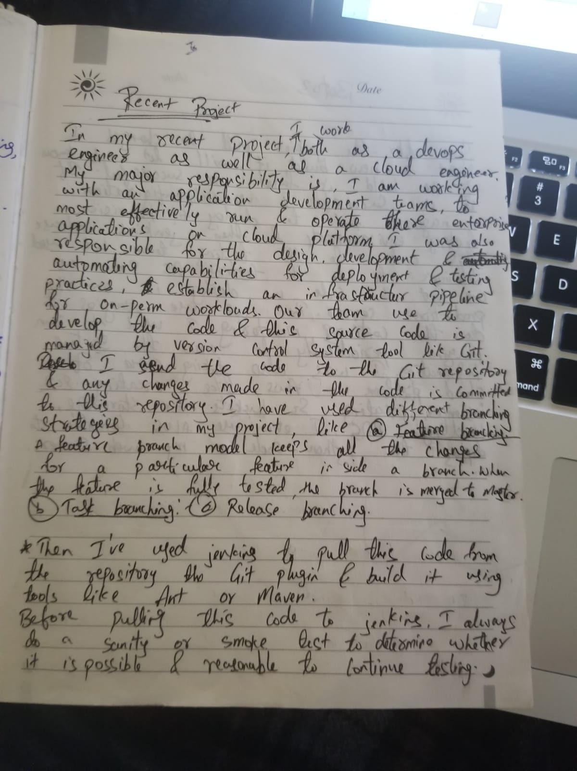

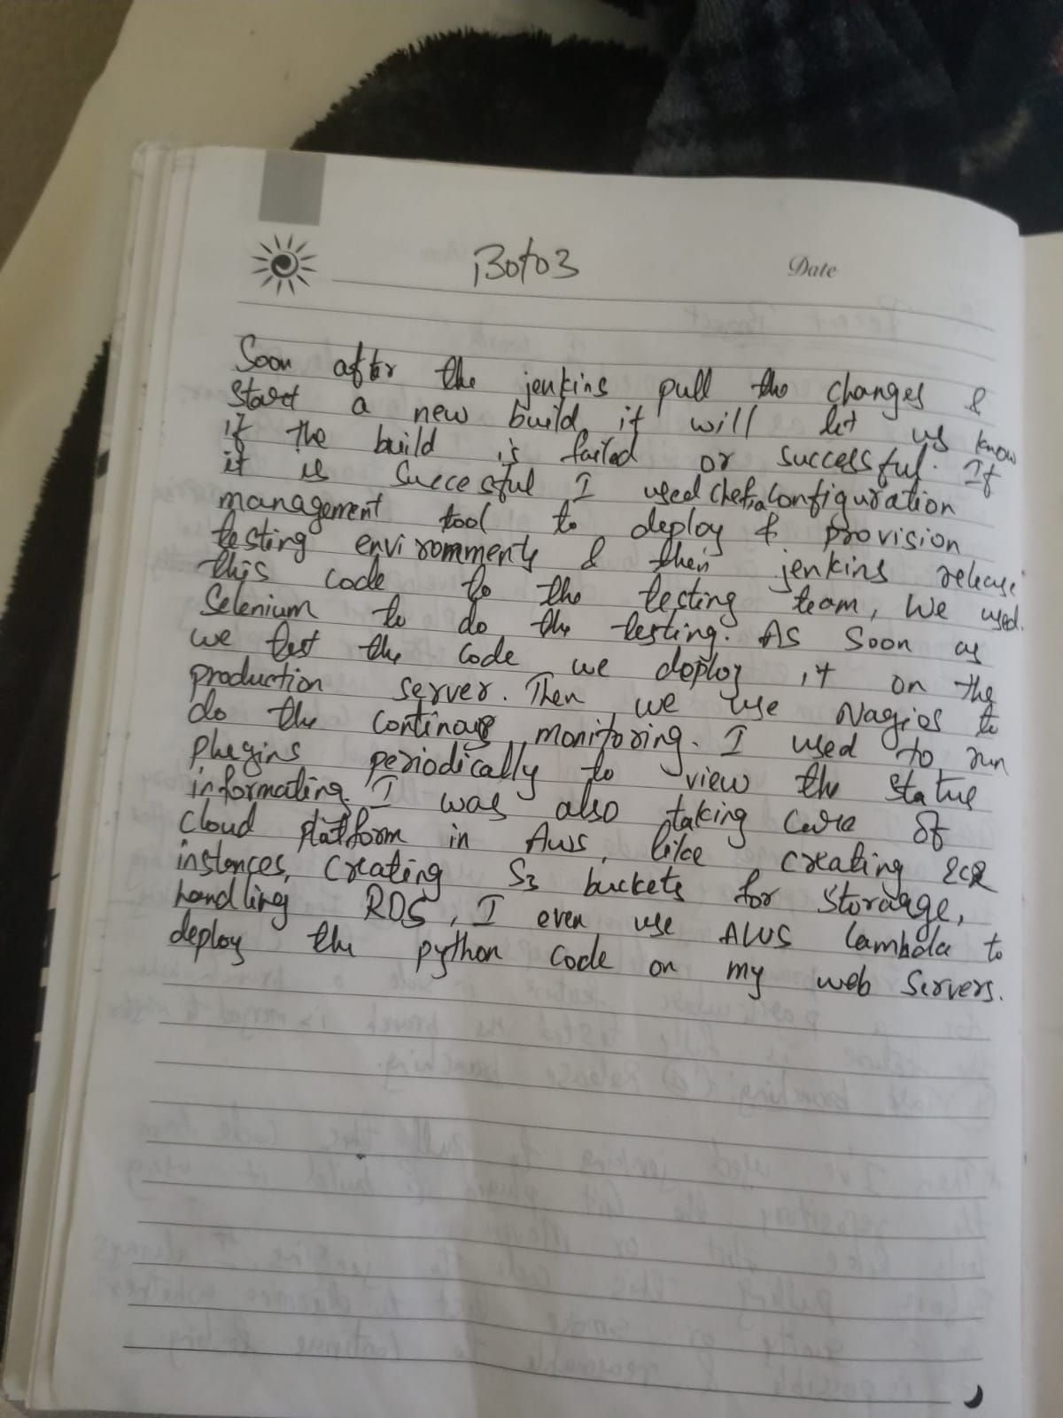

We also used dockers containers to test the code in a cerntalized mechanism where no dev or test team should blame each other if the code breaks or fail, In dockers we add the operating system, application related dependencies and also application server along with the database server and ship onto the production server.

I used selenium along with python to test the web applications, As selenium gives ability to grab the xpath from the web based applications. I run regression test, smoke test and sanity test on a regular basis when the new code has been committed to the Git to make sure new feature doesn’t have any breaks or it should not have any affect on the other functionality of the application.

Well, that’s pretty much it about me.

